**Lexar® JumpDrive® Dual Drive E32c USB 3.2 Gen 1 Type-C™**

128GB

64GB

[Where to buy](https://americas.lexar.com/product/lexar-jumpdrive-dual-drive-e32c-usb-3-2-gen1-type-c-2/)

[Features](https://americas.lexar.com/product/lexar-jumpdrive-dual-drive-e32c-usb-3-2-gen1-type-c-2/#feature-section)[Specifications](https://americas.lexar.com/product/lexar-jumpdrive-dual-drive-e32c-usb-3-2-gen1-type-c-2/#specifications)[Part Numbers](https://americas.lexar.com/product/lexar-jumpdrive-dual-drive-e32c-usb-3-2-gen1-type-c-2/#product-numbers)[Related products](https://americas.lexar.com/product/lexar-jumpdrive-dual-drive-e32c-usb-3-2-gen1-type-c-2/#related-products)

**Features**

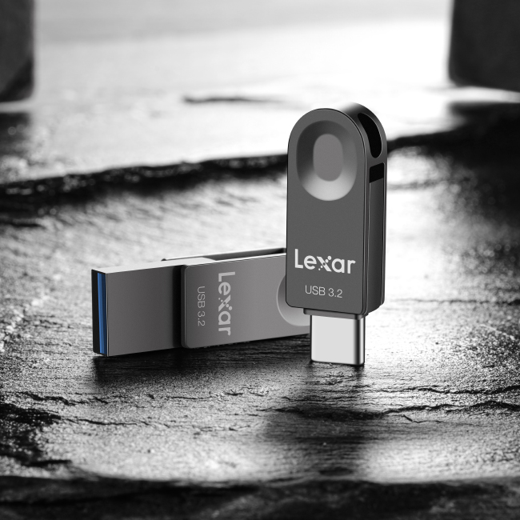

**Super-fast transfer for higher work efficiency**

Powered by USB 3.2 Gen1 performance, JumpDrive E32c delivers high transfer speed with read speeds up to 100MB/s and write speeds up to 30MB/s write1. making it a breeze to transfer files from smartphones, PC and other devices. And for added versatility, the drive is backward compatible with USB 3.0 and 2.0 devices.

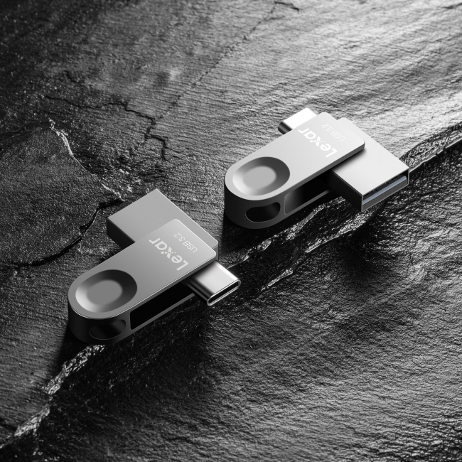

**The power of 2 in 1 flash drive with USB Type-C™ and USB Type-A connectors**

A multi-purpose database suitable to use with PC and smartphones. It is a 2-in-1 flash drive with USB Type-C™and USB Type-A connectors, and is compatible with smartphones, tablets, PC and other devices so you can easily transfer data between multiple terminals without being limited by the size of documents, greatly improving work efficiency.

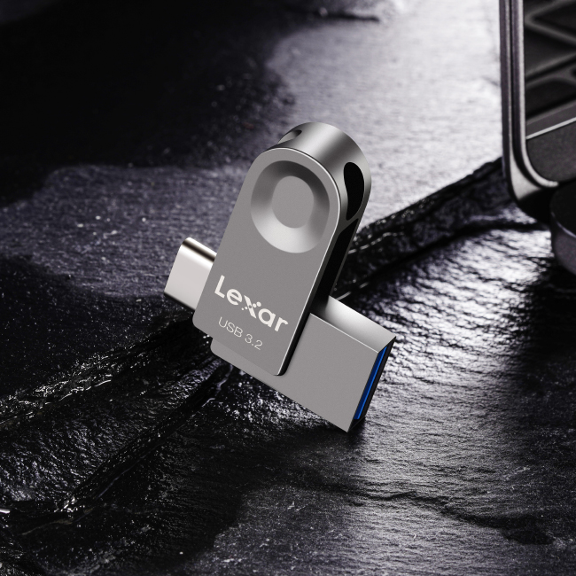

**Durable swivel metallic design**

The convenient swivel metallic design that is collision, abrasion and rust resistant. Compact size with key chain hole making it easy to tether to a key ring or lanyard, so you can bring data on the go.

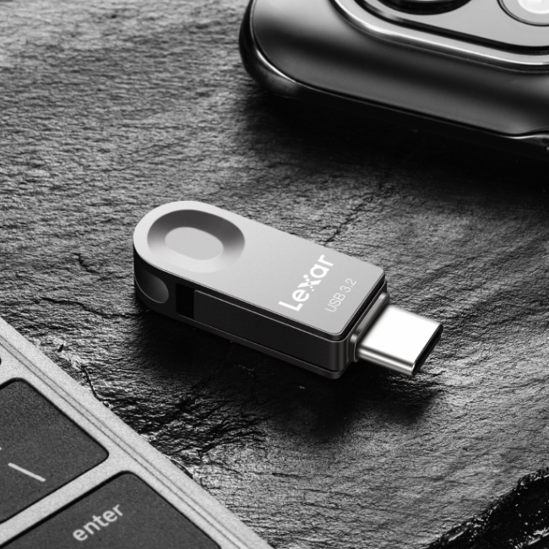

**Security every step of the way**

Are you looking to protect personal information, financial records, or other sensitive files on the go? JumpDrive E32c includes an advanced security solution with 256-bit AES encryption to help protect your essential files against corruption, loss, and deletion. Easily create a password-protected safe that automatically encrypts data. And for peace of mind, files that are deleted from the safe are securely erased and can’t be recovered.

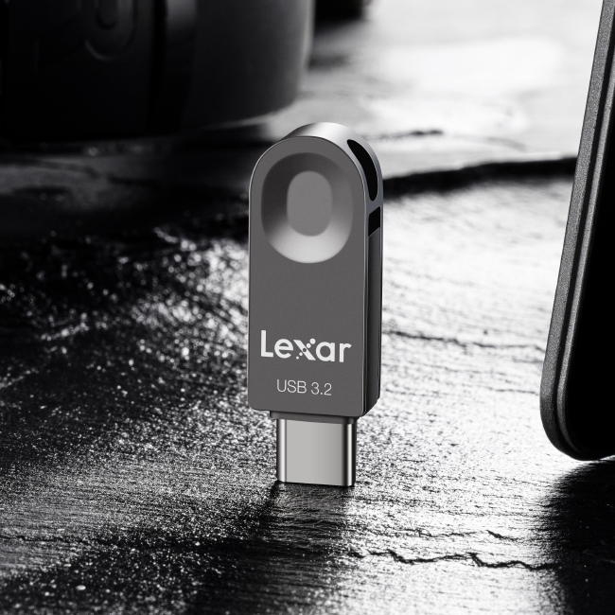

**Save more of what matters**

Available in capacities from 32GB to 128GB. JumpDrive E32c not only allows super-fast transfer of tremendous amount of documents between smartphone, tablet, PC and Macs, smartphones, PC, Mac, and other devices, but also a safe way to backup or archive all your important files.



**Rigorously Tested**

All Lexar products undergo extensive testing in the Lexar Quality Labs, facilities with thousands of different cameras and digital devices to ensure performance, quality, compatibility, and reliability.

**Specifications**

* Capacity

128GB | 64GB

* Color

Tianium

* Interface

USB 3.2 (Gen 1)

* Operating Temperature

0° C ~ 60° C

* Storage Temperature

-20° C ~ 85°C

* Dimension (L x W x H)

40.5 mm x 12.2 mm x 7.2 mm / 1.59” x 0.48” x 0.28”

* Weight

8 g / 0.017 lbs (USB Only)

* Compatibility

PC and Mac® systems

* Warranty

2 year limited warranty